**Example G – Sponsor Invoice**

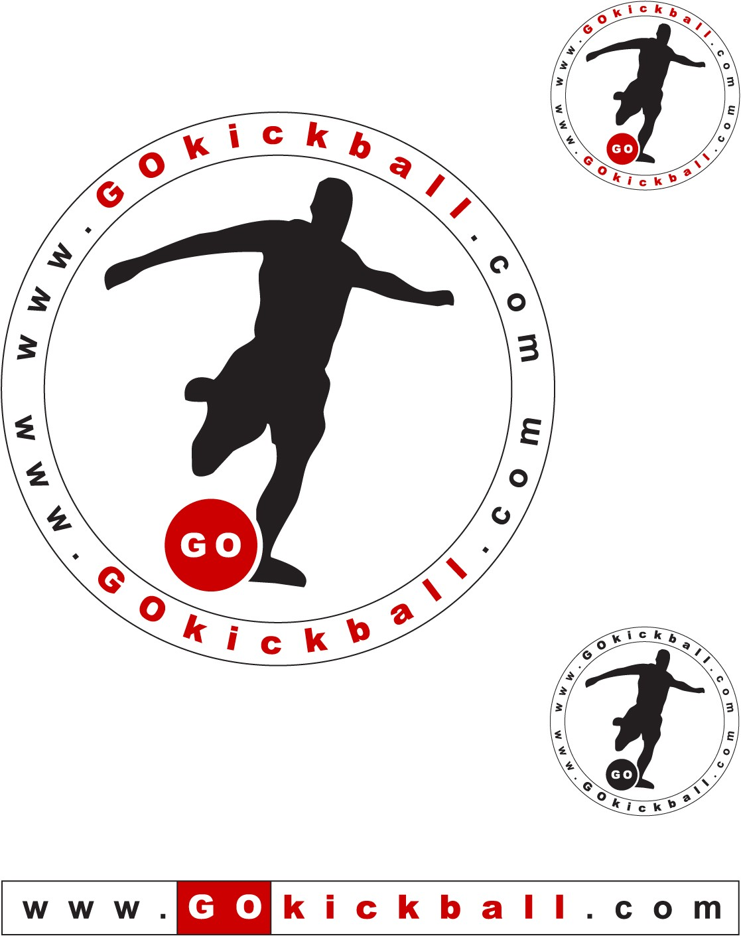

**GOkickball LLC Invoice Date:**  Mar 11th, 2014

5315 Peachtree Ind Blvd  **Invoice Number**: 1

Atlanta, GA 30341 **Sponsor Season**: Spring 2014

(404) 963-6860 **Page**: 1 of 1

[www.gokickball.com](http://www.gokickball.com)

EIN: 743-156049

**SPONSOR:**

Hudson Grille – Sandy Springs

**Season Description Amount Invoice**

|  |  |  |  |
| --- | --- | --- | --- |
| SP 2014 | - League bar sponsor for Sandy Springs leagues  Monday evenings - 6 teams  Tuesday evenings – 12 teams  - T-shirt sponsor – All Spring players city-wide  - Website Sponsor – Hudson Grille Logo  on GKB Atlanta webpage | $600.00  $1,200.00 | $600.00  $1,200.00 |
|  |  |  |  |

**Total Amount: $1,800.00**

*(Due Upon Receipt)*

Account Summary

|  |  |  |  |
| --- | --- | --- | --- |
| **Billed To Date** | **Paid To Date** | **Invoice Amt** | **Balance Due** |
| $0.00 | $0.00 | $1,800.00 | $1,800.00 |

*(Visa and Mastercard are accepted and a 2% processing/trans fee is added)*

**Invoice Comments:**

* Hudson Grille will provide drink and food specials for Gokickballers
* 1st Week Hudson Grille will provide drink discount and 1 free beer pitcher for each team as part of league kickoff

